 | 

Howl's Moving Castle: another door
Game design document
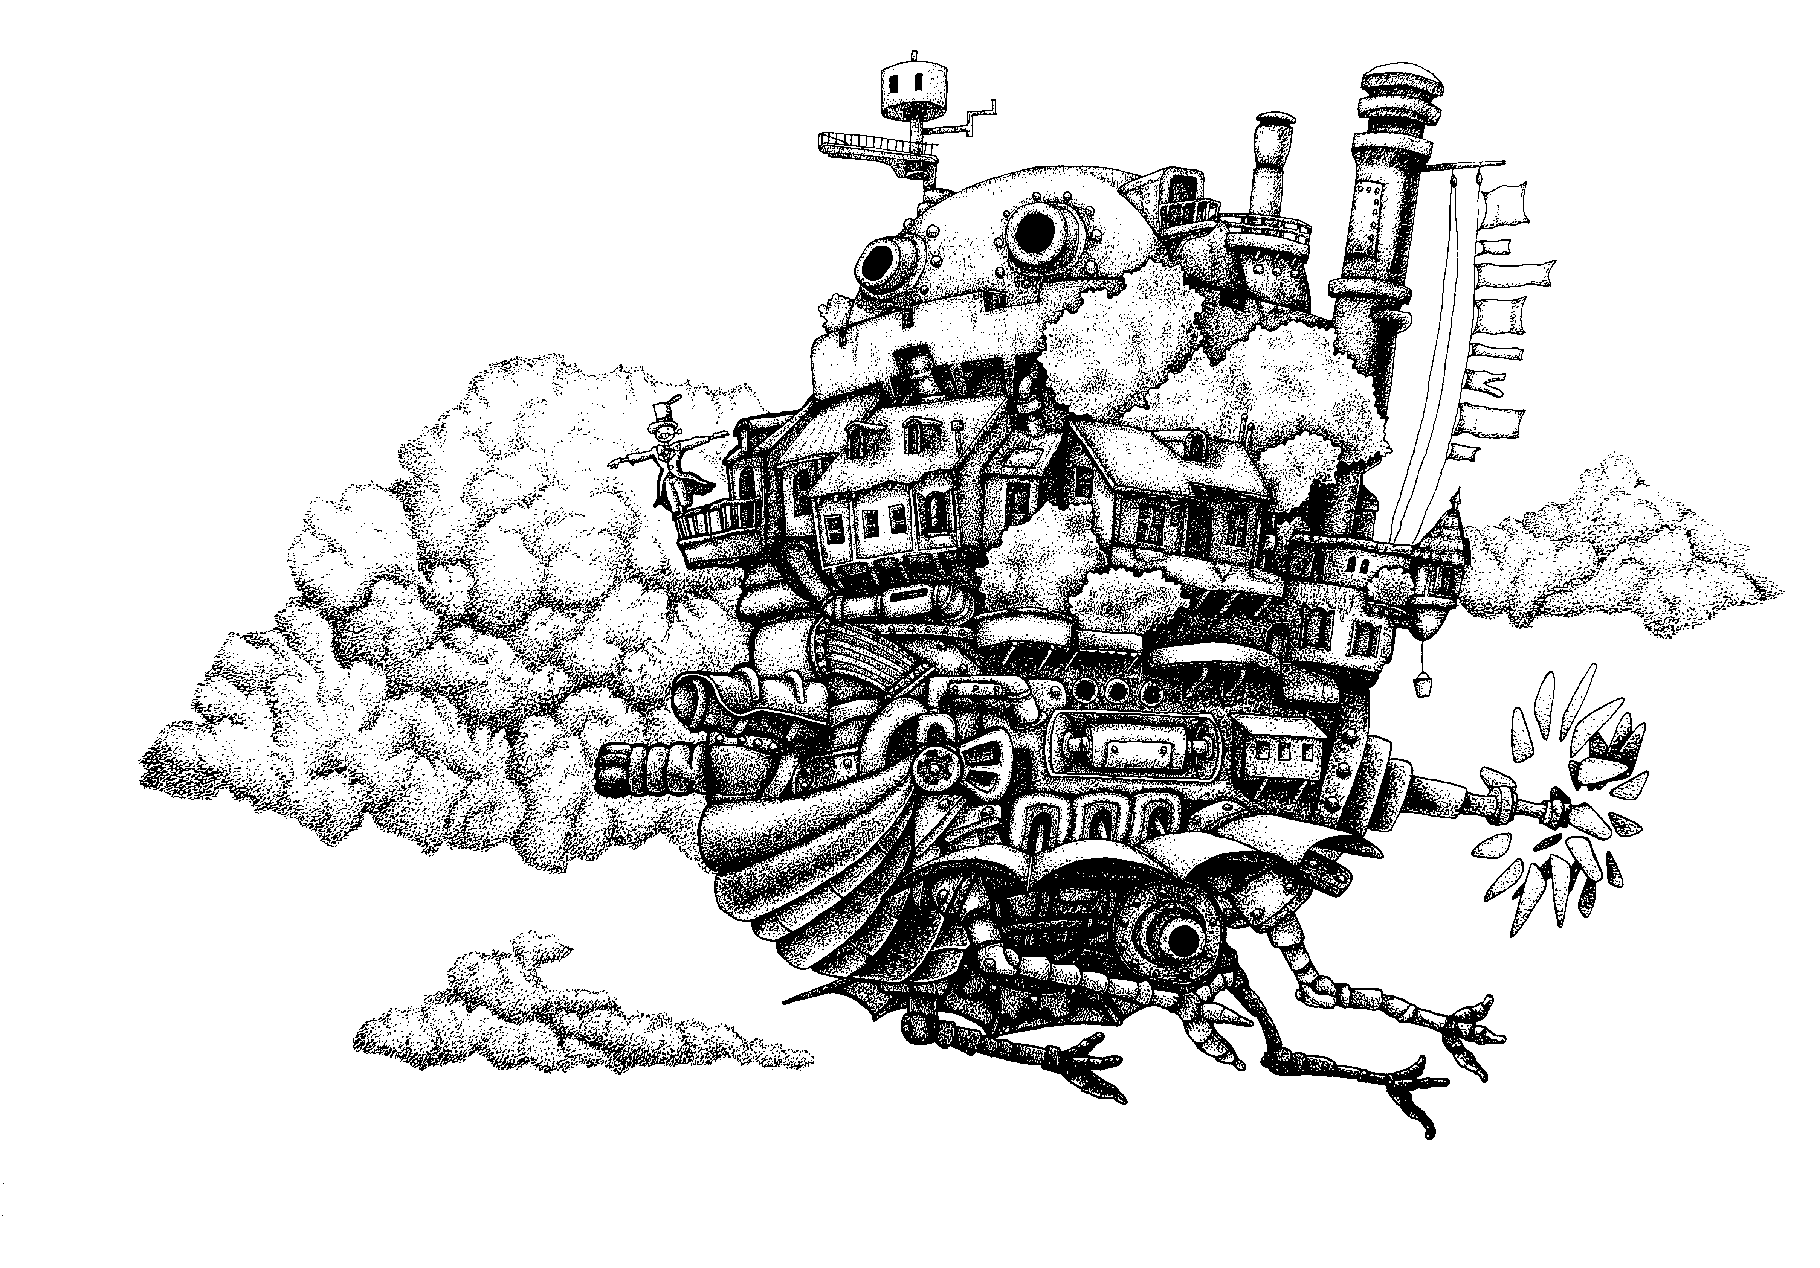

Team7
938320 | Dettori | Francesco
938379 | Iervolino | Riccardo
931468 | Maione | Michele

Index
Change log 1
High Concepts 2
Settings 3
Ingary 3
Radme 3
Ingary under attack 3
Synopsis 4
Past 4
First act 5
Second act 6
Third act 7
Themes 8
World diagram 9
World map 10
Characters 11
Sophie Hatter 11
Howl 12
Layton 13
Before 13
After 13
Madame Suliman 14
Calcifer 15
Heen 16
Markl 17
Witch of the Waste 18

Change log
User | Date | Description
Maione | 14/10/2018 | Created this document
Maione | 18/10/2018 | Added the characters list
Maione | 21/10/2018 | Added image to charactes
Dettori | 22/10/2018 | Writed the overview story
Maione | 23/10/2018 | Added deadlines
Dettori, Iervolino | 24/10/2018 | Writed the game story
Dettori, Iervolino | 25/10/2018 | Writed the characters biography
Iervolino | 25/10/2018 | Story revision
Dettori | 03/11/2018 | Summary of acts
Iervolino | 04/11/2018 | High concepts
Dettori, Maione | 05/11/2018 | Added world maps
Maione | 06/11/2018 | Updated diagrams and maps
Maione | 07/11/2018 | Updated characters layout

High Concepts
After the previous adventure Howl, Sophie, Calcifer, Markl and the witch of the wasted lands live a happy time. Their idyll is interrupted when Suliman informs Howl of the oncoming from the overseas kingdom of some monstrous animals, covered with a strange green mud and ruled as marionettes by spirits similar to those evoked by Howl in moments of despair. The protagonist understands that he is personally involved in the spread of this new evil: years before his classmate Layton, jealous of Howl's powers and his influence on Suliman, had tried to steal Calcifer pretending to be a charming girl. Howl was so deeply infatuated with the image created by the magician that he released umpteen demons of despair once the deception was revealed. Defeated Layton, he had secretly exiled him in a small magical urn, filling it for further punishment with the powerful evoked spirits. During this imprisonment, however, Layton has learned to control the spirits and, once freed, dominates the sentient minds by amplifying their own negative feelings. Without confessing to Suliman, Howl leaves for the other continent hoping to defeat his opponent while keeping the consequences of his impulsiveness hidden, but this time it will be the wizard Layton to prevail. Sophie and her friends must therefore ask Suliman for help, alarmed by the magician's disappearance and fleeing Layton's henchmen, who also lead to the destruction of the castle. Suliman prepares them for adventure and orders Heen, in the form of a warrior, to watch over them. Over the ocean, with the help of the King Breunor ousted by Layton, they retrace the journey of Howl, who now wanders as a child without memory. The team must find Howl and his old age to bring him back to battle, while Layton rallies his forces to attack their kingdom and defeat Suliman too, completing his revenge. Gathering together after growing up in difficulties, Sophie and Howl manage to defeat Layton.

Settings

Ingary
Ingary is in the same condition in which the novel left her, with the peace and meekness that distinguish her. The presence of Layton's monsters is limited to the waste, and instead there is a huge number of n.p.c. and social quest that accompany the exploration of markets, ancient buildings, crowded taverns and city courses, in Kingsbury and Portheaven. The maritime city is full of fishermen, sailors and merchants, while the imperial city is more heterogeneous and available to meet the most unlikely individuals.

Radme
Over the ocean we find the continent Radme. Starting from the small city of Salt Marina it is possible to go through the hills close to the coast in the mainland of the continent. Radme is more arid and poor than Ingary, with vegetation and fauna that recall equatorial climates. His capital was governed by an enlightened king, who, weakened by the mourning of his two sons, fell victim to Layton's power, which exploited his despair. Howl's intervention allows the king to reawake and organize the resistance in a clearing to the north, but in the city the slime of despairing spirits continues to spread, multiplying. In the innermost part of the continent, beyond the marshes, stands the highest mountain, where Layton had been exiled and where it is today his fortress.

Ingary under attack
In the final stages of the game, when the protagonists have returned to Ingary to stop Layton's progression, the cities have become very dark, like the sky and the inhabitants. Only a few are saved from the slime, which drives mad crowds spreading like wildfire.

Synopsis

Past
The novel is about a young woman named Sophie Hatter who is the oldest of three daughters living in the town of Market Chipping in the kingdom of Ingary where many fairy-tales are accepted ways of life. As the eldest, she is resigned to the fact that she will have no chance of finding her fortune, accepting that she will have a dull life running the family hat shop. That is, until she is turned into an old lady by the Witch of the Waste, a powerful witch. Sophie leaves the shop and finds work as a cleaning lady for Wizard Howl, famous in her town for eating the hearts of young women. Sophie soon learns that Howl spreads these rumors about himself to keep his privacy. There are four doors to his castle, only one of which is real, and which is enchanted to open to four different places at one time.
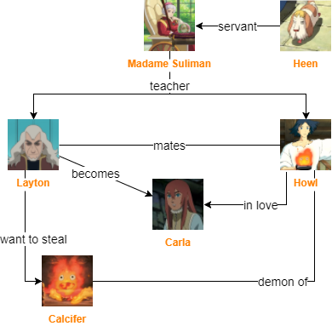

First act
While Sophie, Markl and the land’s witch are in a fair in Portheaven, Howl is summoned by Suliman. When he comes back asks Calcifer to help him making a new color of the door leading to Radme, where he disappear. Few days after, since Howl hasn’t come back yet, Sophie crosses the door and a bunch of monsters covered with green mud follow her inside the castle. They are forced to run away with Calcifer, so the castle collapses on their enemies. In search for help and answers the group goes to Suliman, where they find out the provenience of the danger but not his nature. Suliman orders Heen to join the group to look after them, then provides them a ship to Radme.
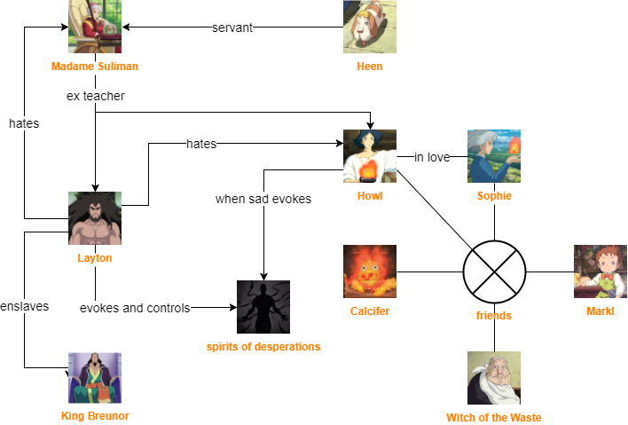

Second act
The group lands in Salt Marina and discovers that the king of Radme has been exiled from the near capital by a powerful magician just appeared from Ingary. Before that, the king had been sick for a while and a deep sorrow had spread around the city, followed by the mug. In the capital they meet a sentinel of the exiled king followed by an orphan child rescued from a river. He explain that the King’s mind was cheated by Layton, an evil magician, until Howl helped him to escape and build a resistance out of town. So the group decides to reach for the king, but soon Layton arrives with his troupes and, before killing the king, tells how he defeated Howl by stealing his manhood and letting him drown in the river in a child-form. In the mean time the group is hidden so they discover that Layton is going to Suliman to ultimate his revenge.
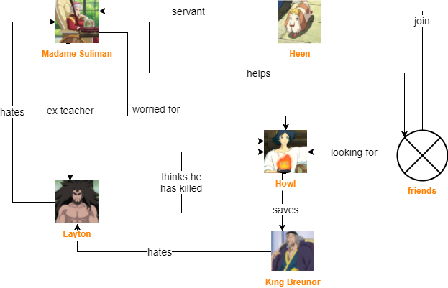

Third act
The group sneaks into Layton’s castle to steel the potion that will make Howl adult again, find the child they met earlier in the capital (that turns out to be Howl survived) and then, reunited, run to Ingary using the boots of the seven leagues to promptly save the situation.
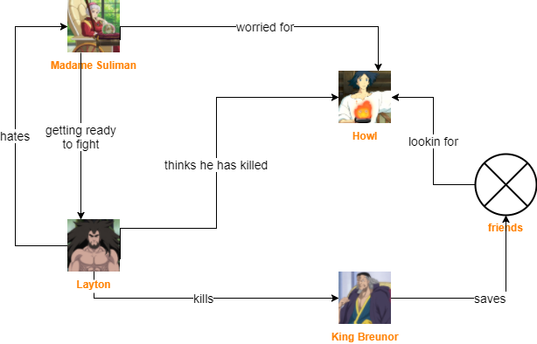

Themes
The hero leaves to redeem a past error (due to his classic flaws) that allowed the bad guy to spread like a disease.
The hero is captured, and his family, led by a brave and inexperienced heroine, embarks on a long journey back to the initial status quo.
They are helped by the old teacher of the hero, by his dog who turns into a warrior, and by the sad ousted king of distant lands.

World diagram
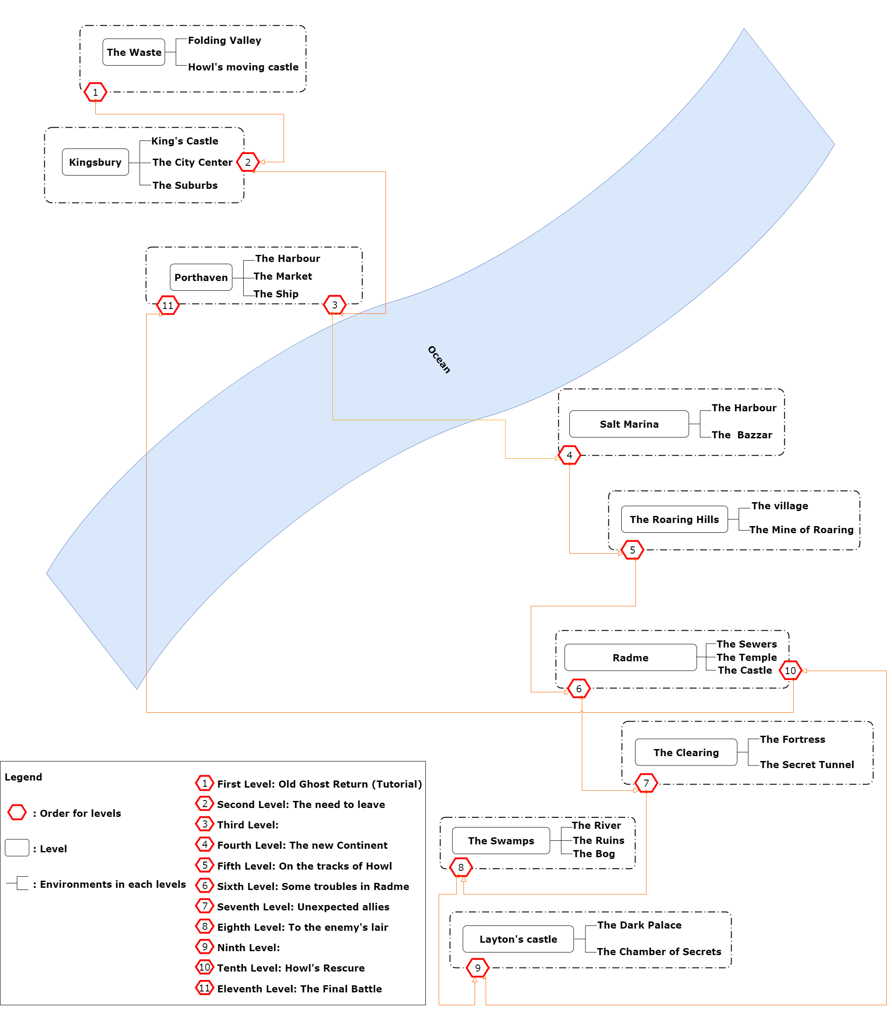

World map
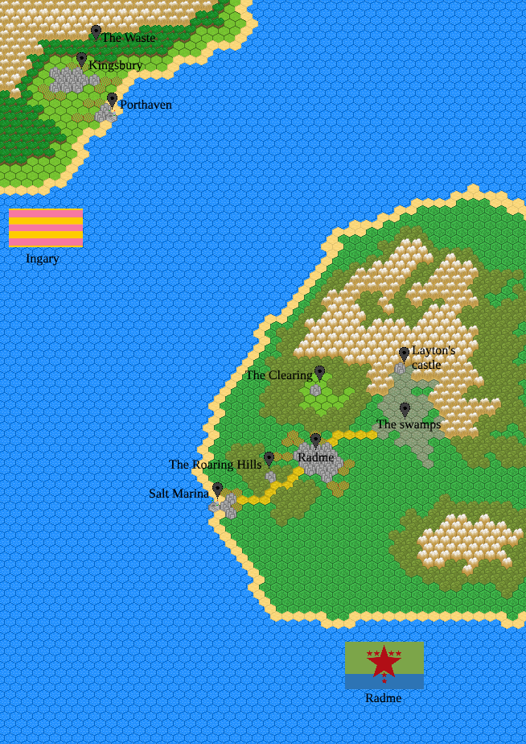

Characters

Sophie Hatter
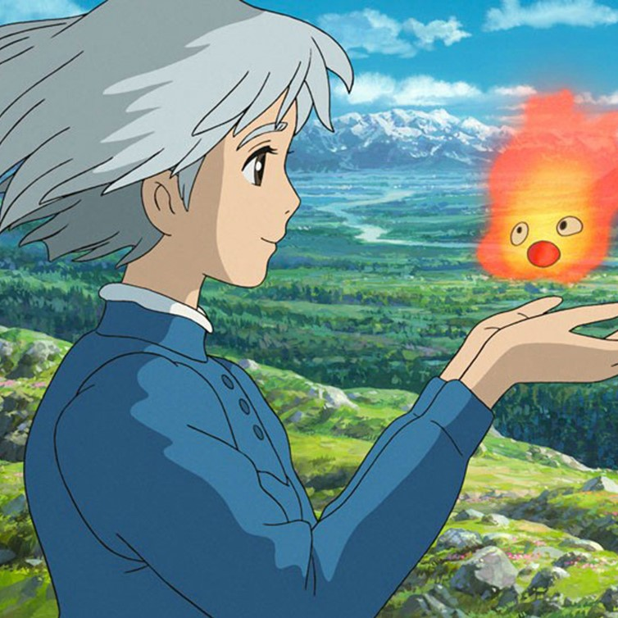
Sophie is a young witch, in love with Howl and friend of all castle guests. Genuinely cheerful and positive, she is able to exert an innate influence on those around her. Sophie, decidedly wise for her age, seems to positively influence the fate of the companies she has to make, and of those she meets. As soon as the scope of the danger is understood, he manages to keep control of the situation and to launch a confident meeting to his destiny, keeping the group's morale high, which in return loves it very much. In Sophie the calm meekness of an elderly lady and the vital energy of a young girl coexist, to which soon the sure pride of a sorceress will soon be added. Sophie has recently discovered her magical potential: she devotes herself for a period to the first experimentation of the magical arts, with howl and Suliman as masters and Calcifer as an ally. It is immediately evident how magic makes it natural, so, once learned how to channel it, it brilliantly overcomes a first training. Meanwhile, his relationship with Howl is strengthened, and their life as a couple proceeds happily, except for some hitch linked to Howl's childhood character.
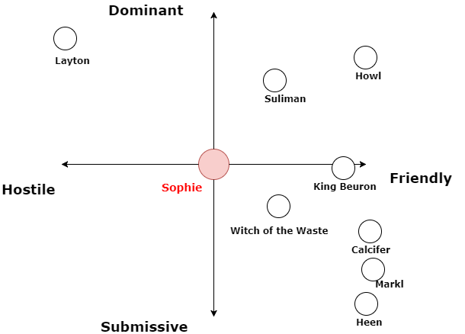

Howl

Howl is a powerful wizard, in love with sophie and owner of the castle. He can rely on the support of his friend fire demon Calcifer and the young apprentice Markl. It is very vain, it dyes the hair and pays great attention to dress. When he is depressed he evokes the spirits of despair, accompanied by rivers of green slime. Howl is extremely good, but rather childish and narcissistic, and despite great security flaunts, intervening whenever essential, has a tendency toward depression and a deep fear of failure. The latter led him to several phases of paranoia and to an evasive behavior with the teacher Suliman that persists even after finding more emotional stability thanks to Sophie. His new relationship is a big change for his rigidity, but he has a powerful influence on him. Immediately recognizes its green slime on Layton's monsters come to Ingary. Howl recalls that time when his apprentice mate (Layton) tried to steal Calcifer from him while they were still studying at Suliman. He decided to make him fall in love in the role of a woman (Carla), knowing his weaknesses, but once he entered the house, revealed himself, he was quickly defeated by the demon whose power he had underestimated. Howl then yes I despair for the sincere infatuation evoking a myriad of spirits and for a teenage revenge he locked them all with Layton in a small urn.
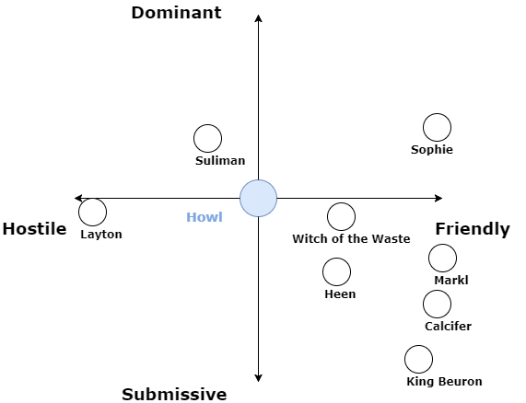

Layton

Before
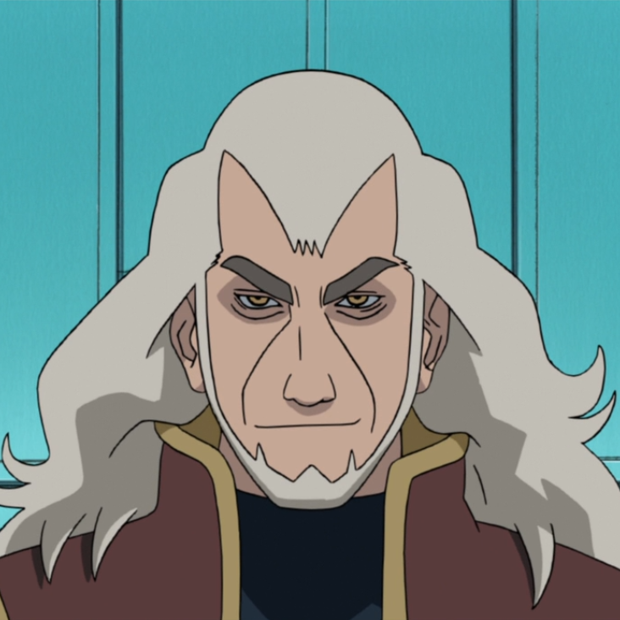
Egocentric and maniacal, Layton has developed a symbiotic bond with the slime of the spirits, which allows him to control it by spreading despair on everything that crosses his path. He intends to take revenge on Howl, for the humiliation of having been defeated and for the cruel way he was punished, and Suliman, for having preferred years ago Howl despite his power certainly hiding a misconduct or otherwise a big fortune. Layton, in fact, was Suliman's apprentice, and he had great admiration for her. The arrival of Howl and his rapid progress in the magical arts did not bother him as much more experienced than he was. But when Howl overtook him abruptly he decided to jealousy about the teacher to investigate, and he learned of the existence of Calcifer. When he failed his awkward attempt to steal the demon found himself condemned for years in an urn with the demons of despair, merging with them.

After
A fortuitous finding of the urn by some scholars of the other continent leads to its liberation.
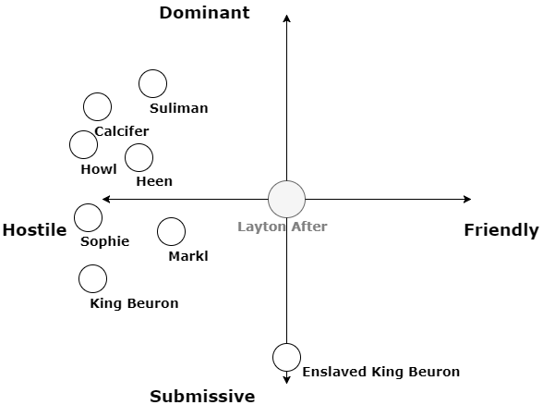

Madame Suliman
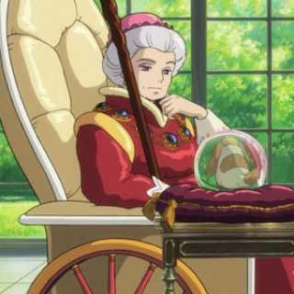
Suliman is the sorceress of the king of Ingary, and as such is reputed to be the greatest sorceress of the kingdom. She was a teacher at Howl, for whom she is constantly apprehensive and whose behavior can not be explained. Despite his powers he can not move, and he gets tired easily. This leads her to play a marginal role in the action, but through Heen she is constantly in contact with the group, and controls a small network of emissaries on Radme. He does not know that Layton has merged with the spirits of despair after having fought with Howl and must accept his disappearance. He is aware of several places where Heen may have been spotted.
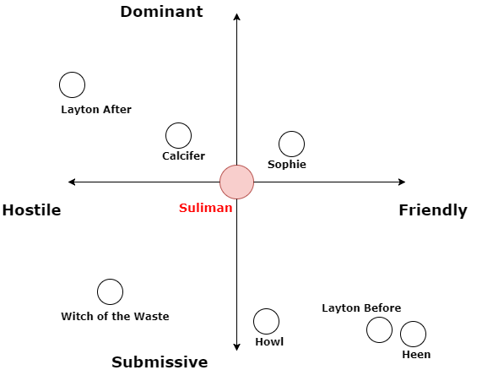

Calcifer
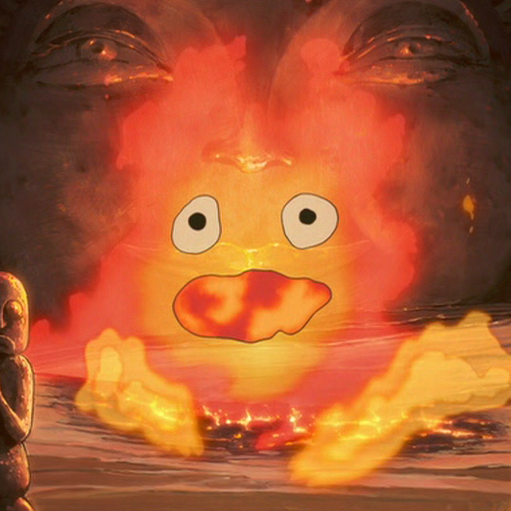
Calcifer is a young and powerful fire demon, freed from the magical power of Sophie. Now it is extremely autonomous and can move to your liking. is able to amplify the magical power of magicians with whom it has a deep bond. He often moves inside an exoskeleton, such as a knight's armor, which allows him to disguise himself among the people. It is capricious and easily complains, but it is also very determined, and has a profound knowledge of all that is magical. Calcifer recognized Layton's intentions as soon as he saw him enter the castle, while Howl was deceived by the transforming transformation into Carla. After defeating him with Howl he was deeply concerned by the mixture of wizard and spirit that Howl had created, and suggested that he be unobtainable, so Howl hid him in a remote land. Since he was freed from the contract Calcifer is even more tied to his friends, and hardly spends a day away from them. Since the castle has expanded, he travels to the most exotic places in search of flowers.
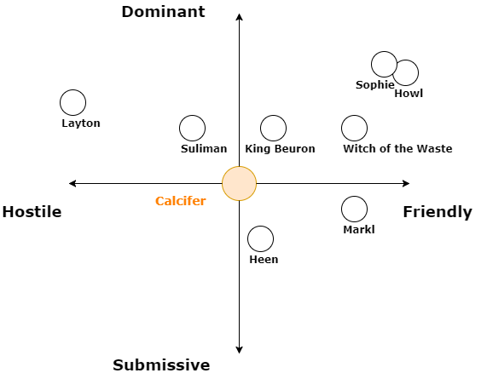

Heen
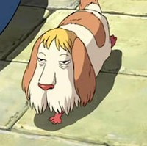
Heen is the most faithful servant of Suliman. Known by everyone in the form of a dog, he has obtained the ability to return to his state of great human, even if incomplete and similar to a golem. His will is all about serving Suliman and Sophie who have a great influence on him. However, while traveling with the group, he pays attention to the eventual discovery of one of his parts, which leads him to a better state of consciousness and health. Heen is actually the greatest warrior of Ingary, who years ago was cursed by the witch of the moors, and decomposed in different parts. Although Heen remains the most important part of the body, its other parts have been sold or lost by the witch over the years. Suliman has been rowing for years to reassemble but is too old for a mission like that and has had little success.
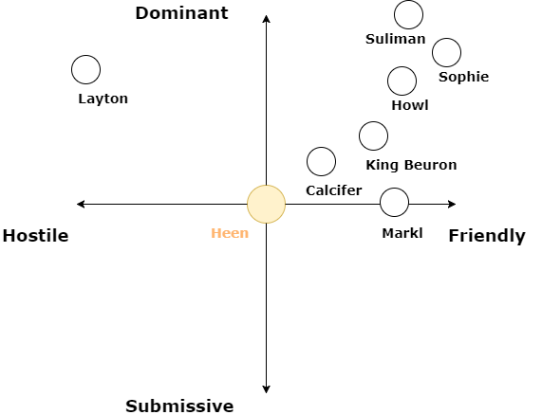

Markl
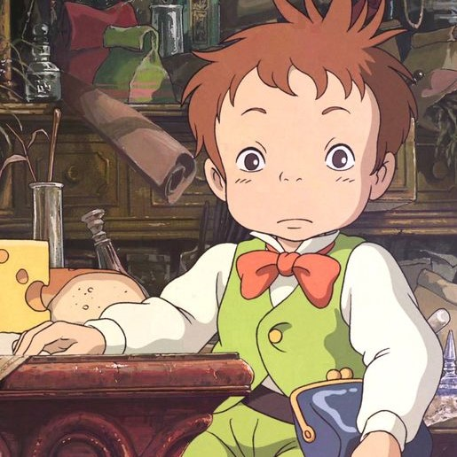
Markl grew quickly, in a few months he gained several centimeters and became a good level apprentice. Motivated by the presence of Sophie Markl has made much progress, and now controls a discreet power. Nevertheless, he continues to show a certain insecurity, and he asks for help with his own spells.
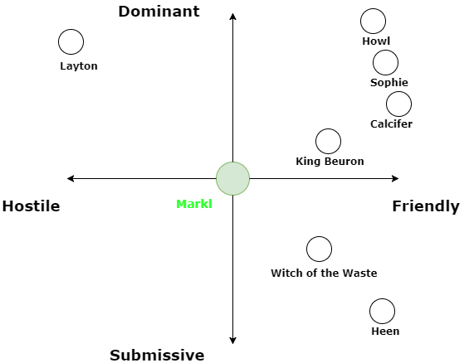

Witch of the Waste
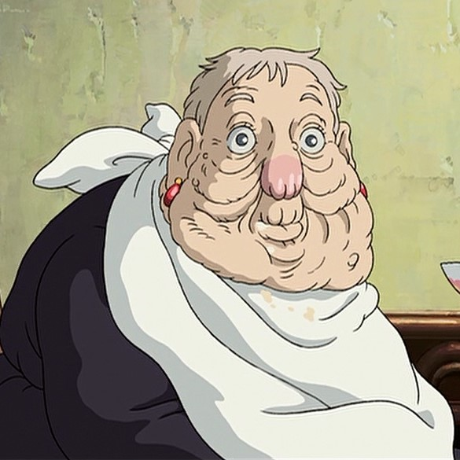
Is a completely harmless old woman. He has a great experience with magic but his brain is too old to be able to use his knowledge in a functional way. On many occasions his intervention adds an element of randomness to the situation, as it is very naive and curious. He does not remember where he lost or who sold the parts of Heen, but often a small incentive is enough to start rebuilding. Help the group as a naughty counselor. The most powerful and arcane spell that the witch has ever performed allowed her to form a puzzle with parts of Ingary's most powerful warrior, obtaining a prodigious object from each. Unfortunately, over the years it has lost or sold them all.
